School Counseling Program Newsletter
Shandrai Silva, School Counselor | April 2018

Counselor Message  Happy Spring! It’s hard believe we’re in the last nine weeks of the school year. It’s been a great school year thus far! I can’t wait to see what the last nine weeks bring!  In March, our students had an opportunity to participate in a school-wide service project. We collected pull tabs for the Ronald McDonald House of Charlotte. Together, we collected about 25lbs of tabs, that’s equivalent to approximately 2500 tabs! Way to go Hawks Nest. Your bucket filling will help the Ronald McDonald House of Charlotte provide a home away from home for families of children receiving medical treatment from area hospitals.  This month in classroom guidance, we will continue to learn about College and Careers. Last month, we focused on college. This month, well will focus on careers. We are excited about Career Day on April 27th.  As we approach the end of the school year, students are encouraged to keep working hard and to do their best always.  How to See the School Counselor  Classroom guidance classes weekly or biweekly based on grade levels specials schedule. Small group and individual counseling by self -referral, parent referral, teacher referral, administrator referral or counselor initiated.  Contact School Counselor at 704-866-8467 or sosilva@gaston.k12.nc.us | Home of the Hawks    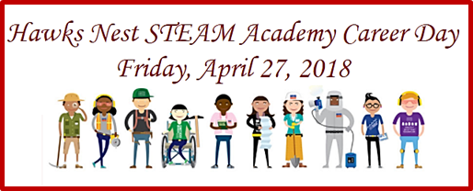  Friday, April 27, 2018  *Wear College Tshirt/Shirt  April is Child Abuse Prevention Month  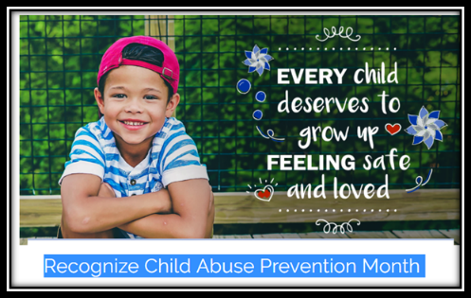https://www.preventchildabusenc.org/get-involved/recognize-child-abuse-prevention-month  http://preventchildabuse.org/  April is Autism Awareness Month  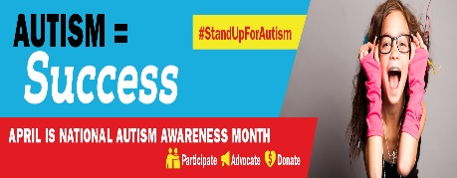 | Character Education  “We’re Soaring with Good Character”  _____________________________  The character trait of the month is Honesty. Honesty means being truthful in what you say and do.  ________________________________  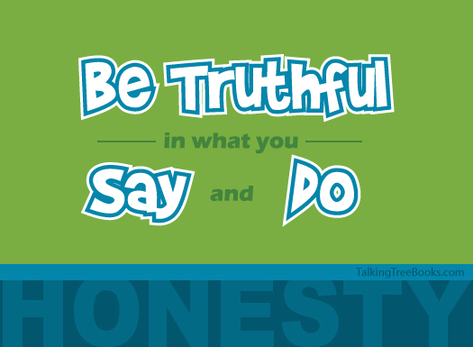  "Be honest in what you say and what  you do." -Talking with Trees Books  Three Tips to Help your Kids Learn Honesty:  - Talk with your children-beginning very early- about how much you value honesty in your family.  - Model honesty for your children-not only in your words but also in your lifestyle  - Let them know that you put more emphasis on their honesty than on the punishment for their dishonest behavior.  Joanne Stern Ph.D., Psychology Today  https://www.psychologytoday.com/us/blog/parenting-is-contact-sport/201103/teaching-your-kids-be-hones  “Intelligence plus character- that is the goal of true education.”  Dr. Martin L. King, Jr.
http://www.autism-society.org/get-involved/national-autism-awareness-month/

